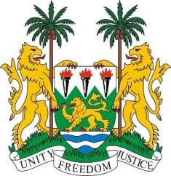
SIERRA LEONE

27th Session of the UPR

MOROCCO

2 May 2017

Mr President,

Sierra Leone warmly welcomes the distinguished delegation from Morocco to this third cycle and thanks them for today’s presentation.

My delegation commends the Government of Morocco on its efforts to protect the rights of asylum seekers and migrants - as seen in the enactment of the Trafficking in Persons Act of 2016, the regularisation of migrants and the recent granting of asylum to over a thousand refugees. Equally notable was the implementation of the gender equality plan (2012-2016) and the child protection program (PPIPE of 2016-2020).

Since 1993, Morocco established a moratorium on the death penalty and has been considering the abolition of capital punishment. Furthermore, their National Human Rights Council enjoys an “A” status accreditation, and between 2013 and 2015, Morocco has contributed to the OHCHR.

Sierra Leone makes the following recommendations:

- Strengthen measures aimed at eradicating child marriages and expedite the enactment of legislation abolishing forced marriage of children.
- Continue to work with the OHCHR and UNHCHR to re-establish the humanitarian aid programme for the West Saharan population.
- Guarantee the full and equal access to socio-economic resources, (including access to tertiary education and traditional language classes) for the Amazigh’s and Saharans/Saharawi.

Finally, Sierra Leone wishes Morocco a successful completion of its review.

Thank you, Mr President.

